The Atlanta Braves: Markets and Marketing

Market Structure Mystery

Author

Bryan Wallace

Editor

Chris Cannon

Market Structure Mystery

LESSON DESCRIPTION
This lesson serves as a review of the four market structures. It should NOT be used until students have a working knowledge of the main characteristics and the associated vocabulary of each of the four structures.
Students will examine the components of different market structures within the context of an Atlanta Braves game. They will begin with a guessing game to familiarize themselves with prices of a wide variety of goods and services available at Truist Park. They will then familiarize themselves with the important elements of the four market structures through a sorting activity. Finally, students will use factual clues from four different types of goods and services available at the game to determine which good or service represents which market structure. Extension activities for AP students include a closer look at price discriminating monopolies and the evolution of Dynamic Pricing as well as answering a key question regarding perfectly competitive firms.
ESSENTIAL QUESTION
- How do the four market structures of perfect competition, monopolistic competition, oligopolies, and monopolies manifest their differences and similarities in actual market conditions?
- How are different market structures related to/affected by the concepts of barriers to entry, number of firms in the industry, product differentiation, and ability to control price?
CONCEPTS
- Perfect competition
- Monopolistic competition
- Oligopoly
- Monopoly
- Price discrimination (AP extension)
- Consumer surplus (AP extension)
- Opportunity Cost
GEORGIA STANDARDS OF EXCELLENCE

SSEMI3 Explain the organization and role of business and analyze the four types of market structures in the U.S. economy.
b. Identify the basic characteristics of monopoly, oligopoly, monopolistic competition, and pure (perfect) competition with regards to number of sellers, barriers to entry, price control, and product differentiation.

TIME REQUIRED
55 minutes (75 minutes with optional extension activities)
- Opening and ballpark prices guessing game – 15 minutes
- Market structure sorting activity – 15 minutes
- “Which market structure am I?” activity – 15 minutes
- Closure and assessment – 10 minutes
- Price discrimination reading and analysis – 15 minutes
- Perfect competition key question – 5 minutes

MATERIALS
- Slides 1-25
- Activity 1: “A Day at the Ballpark”
  - Handout 1: Product/Price Matching. One per student.
- Activity 2: “Market Structure Matching”
  - Handout 2: Market Structure Element Cards. Laminate if possible. Make one set of cards for each group.
  - Handout 3: Blank Venn Diagram sheet. Laminate if possible. One per group.
  - Handout 4: Completed Venn Diagram sheet. One per student. You will distribute these at the end of Activity 2 as a review aid for students.
- Activity 3: “Which Market Structure Am I?”
  - Handout 5: Braves Product Market Facts. Laminate if possible. One set per group.
  - Handout 6: Market Structure Quadrant Sheet. Laminate if possible. One per group.
- Article 1: Braves join new trend in ticketing: dynamic pricing
- Article 2: Impact on secondary market a challenge for dynamic pricing

PROCEDURES
- Introduce the lesson by showing the title slide (slide 1) and asking students if they have ever been to a Braves game. If they have not been to a Braves game, ask them to think about some sort of sporting event or even a concert. Ask them to make a quick list in their notes of things they purchased at one of these events and what they remember paying. Ask a few of the students to read their purchases and prices to the rest of the class. Finally, have a brief discussion about whether they were satisfied with the prices what they purchased and whether they felt like the prices were reflective of the value of the good or service. Remind them that prices are often substantially affected by the kind of market the product exists in.
- Tell students they are going to familiarize themselves with the goods and services available at the Braves game by playing a price guessing game. At this point, break students into groups of four or five students. They will remain in these groups for the rest of the lesson.
- Show Slide 2 on the screen and tell students they are going to attempt to match the goods and services in Column A with the prices in Column B. Distribute a copy of Handout 1 to each student. There are 20 goods and services and 20 prices. Note that some of the prices (e.g. $5.00) are used more than once because some items in Column A have identical prices.
- Give the groups approximately five minutes to try and match the columns. Then reveal the answers on slide 3.
- Ask students whether they think the prices accurately represent the value of the products. Ask them to specifically identify a product or two that they think is appropriately priced, underpriced, or over-priced. Remind them again that prices are affected by market structures. This will give you some talking points about price control in different market structures as you do the next two activities. Students will likely identify more value in products that exist in perfect competition, and will likely see products generated by a monopoly as being potentially overpriced.
- Move on to slide 4 and remind students of the four market structures. Tell them that they will do a short sorting activity to refresh their understanding of the important characteristics of these market structures.
- IMPORTANT: The next activity will use a different set of characteristic cards depending on whether you teach an on-level class or an AP class.
- Move to slide 5 and Activity 2, the “Market Structure Matching” activity. The student instructions are contained in the slide and are as follows:
  - Each group will be given a blank Venn Diagram with a space for all 4 market structures.
  - Each group will also be given a set of “Market Element” cards that describe different elements of markets.
  - The students will try to place the appropriate cards in the left column of the market structure sheet with that characteristic.
  - Note: Remember, some elements may apply to more than one market structure and some will only apply to one structure.
  - The handout material can be found at the end of this document and will differ slightly depending on whether you have an on-level or AP class.
- Give students 5-10 minutes to sort the characteristics into the appropriate market structures. Keep in mind that the characteristics are generalization as specific elements within the markets can vary. For example, the number of firms within each market can vary from industry to industry. This may generate some questions from students, but remind them that the characteristics are designed to represent the typical industry and they should choose the MOST appropriate market structure.
- The solutions are represented in Venn diagram format on slides 6 & 7 for on-level and AP classes respectively. Show these to students when they are done with the activity to confirm that they have sorted the characteristics correctly. At the end of the activity distribute Handout 4 for each student to use as a review tool for market structures.
- Show slide 8 to introduce Activity 3: “Which Market Structure Am I?”. Explain that they are going to examine markets through the lens of attending a Braves game. Ask them to think about all of the products they listed in Activity 1 (product and price matching activity) and tell them they are going to see if they can identify a product that matches each market structure. Here is a script to read to students before the activity:
  - Now that you have re-familiarized yourself with the characteristics of each market, let’s look at a real-world example. On any visit to an Atlanta Braves game at Truist Park, you can see a wide variety of product markets. You probably identified some of these products in the opening activity. But can we find an example of each of the four market structures?
  - For this activity, you are going to be given a variety of facts about products marketed at a Braves game. It is going to be your job to take these facts and determine how they might fit into the market structures you just reviewed. Looking at your market structure pages, try to place each fact into the correct quadrant of your page, using the characteristics you identified as a guide. As you place the facts, try to determine which product represents which market structure. Some facts may seem contradictory or confusing. Talk with your group about these facts as you try and match products to market structures.

- Slide 8 prompts students about the next activity.
  - Give each group an entire set of the “Braves Product Market Facts” listed at the end of this lesson.
  - Give each group a copy of a Market Structure Quadrant Sheet found at the end of this lesson.
  - Instruct them to study the facts in their groups and to try and sort them into the right quadrant of each market card. They may consult the Venn Diagram from Activity 2 for guidance. These will help guide them in trying to determine where to place the facts from this activity. Note that the teacher is not identifying which four products are being examined. The students should determine this as the activity moves forward i.e. do not tell students that the four products are bottled water, apparel, parking, and tickets. Otherwise they may be tempted to group the facts before they place them in a category rather than evaluating each fact independently.
- Give students approximately 10 minutes to group the facts. After the allotted time, ask each group to make a conclusion about which product matches which market structure and ask them to explain why they made the choice they did.
- After they have made their guesses, progress through slides 9- 12 to let each group see the correct product/market pairing. Give particular emphasis to reinforcing the language of the standards by analyzing each structure/product pairing in the context of number of sellers, barriers to entry, price control, and product differentiation.
- ******If not doing the two AP extension activities, you can move directly to procedure 29 in the instructions.*****
- Slides 14-22 contain an optional short activity for AP students regarding Monopolies and Price Discrimination.
- Begin this activity by reviewing the principles of a price discriminating monopoly. For an easy teacher review, pre-read slide 14 and the accompanying graph. Review the ideas of consumer surplus and remind students that D=MR for a price discriminating monopolist. Here are some key points to discuss for each slide:
  - Slide 15 - The Braves are the only MLB franchise in Georgia. They have a geographic monopoly. Because of this, they can determine the number of tickets available and they have complete autonomy in setting the price of those tickets.
  - Slide 16 - Much like airlines and hotels, the Braves can find ways to determine who is willing to pay more or less to see a game. The traditional way of doing this has been to offer different prices for different seats. Ticket prices can be as low as $5 for a general admission ticket or over $200 for the best infield seats. This range lets consumers self-identify how much a braves ticket is worth to them and helps Braves minimize consumer surplus as each customer presumably pays close to his or her maximum price for a ticket.
  - Slide 17 - This is where it gets tricky. Unlike airlines or hotels, baseball tickets can be resold because teams do not require the person that is admitted to the game to be the person that purchased the ticket. Additionally, in most states it is legal (with certain restrictions) to resell event tickets for more than the original value of the ticket, or its “face value”. This means that if demand for a game is higher than the Braves anticipated, someone can resell an original ticket for more money. This has led to the formation of an entire industry of resellers, with internet companies such as StubHub, Vividseats, and Tickpick.

- Show slides 15 & 16 and have students review the first two requirements of price discrimination. Discuss with students how the Braves meet these requirements before clicking through to the answers.
- Next move to slide 17 and ask students if the Braves meet this requirement. Someone in the class will likely say no and point out the presence of a formal or informal secondary market where tickets can be resold. If no one brings this up, prompt students to recognize this before clicking through to the last part of the slide.
- Move to slide 18 and distribute Article 1: “Braves join new trend in ticketing: dynamic pricing” (In addition to being linked in the Materials section, it is also hyperlinked in the header. After reading the article, ask students to summarize the concept of Dynamic Pricing before clicking through to the explanation on the slide. Here are some key points to discuss for this slide:
  - As mentioned, teams have traditionally segregated the market only through offering different prices for sitting in different parts of the stadium. These prices are determined many months in advance and do not change throughout the season. The next evolution in ticket pricing was something called Variable Pricing. This let teams charge different prices for different games, usually based on factors like the day of the week or the traditional popularity of an opponent. These prices were still determined far before the season and did not change during the season despite changes in consumer demand. The newest development is called Dynamic Pricing. Dynamic Pricing is possible because of the availability of internet-based ticketing systems that allow teams to change ticket prices in real time. Under this method, ticket prices can change literally right up to moments before the game. Teams are now able to set prices throughout the season in response to factors like weather, current sales, promotions, and opposing team records. Teams can even adjust prices for attractive pitching matchups or if a player on one of the teams is accomplishing something significant, like a hitting streak or approaching a home run record.
- Next show slide 19 and have the students read Article 2: “Impact on secondary market a challenge for dynamic pricing” (also found in the Materials section and hyperlinked on the slide). Ask them to summarize how Dynamic Pricing can how increase revenue for a team. Be sure to make them include the concept of consumer surplus. Dynamic pricing attempts to reduce consumer surplus by identifying when certain factors might make customers willing to pay a higher price and raising prices accordingly, and conversely lowering prices when demand falls to capture consumers who identify the price as being above their maximum willingness to pay. Here are some additional points to discuss for this slide:
  - Dynamic pricing is actually a response to the existence of a secondary market. Teams that sell tickets at a fixed cost are vulnerable to changes in demand for different games. In this scenario, the team potentially loses money for higher demand games as resellers are able to sell a ticket for more than face value. In the reverse situation, where demand is less than anticipated, fans might be unwilling to pay a fixed cost they deem to be too high and the team faces lower attendance. Dynamic pricing essentially attempts to mimic the secondary market by responding to anticipated changes in demand.
- Finally, ask students to attempt to explain why Dynamic Pricing has not eliminated the secondary market. Draw attention to the self-imposed price floors and ceilings that exist for teams as explained in the article. Here is a summary of the explanation:
  - For lower demand games, The Braves, and other sports teams, are usually constrained by a self-imposed price floor. Why? Because teams are unwilling to charge a lower ticket price than the per-seat price they have offered their season ticket holders. Season ticket packages account for a large and secure portion of revenue for a team, and if season ticket holders saw ticket prices dip below the price they had paid, it would erode demand for these packages. Conversely, most teams are unwilling to set prices too high, even for games where demand is anticipated to be very high. Why? Because teams are protective of the relationship between the team and its fans. Charging prices that fans might see as exorbitant has the potential to anger fans and damage this relationship. This doesn’t apply to resellers since fans have no affiliation or loyalty to these companies and understand they are simply a market for tickets that will charge the maximum price that demand allows.
- Slide 20 contains two interesting facts to remind students that changes in supply and demand are still the primary drivers even in a monopoly market and Dynamic Pricing must take ultimately try and monitor these changes to be effective. Example 1 shows how winning can affect demand by impacting consumer tastes and preferences and raising prices. Example 2 shows how changes in supply can lower prices.
- Slides 21 & 22 show how Dynamic Pricing affects ticket prices. Direct students to take a close look at the ticket prices displayed on the slide. Have them also look at the standings below the prices. Then ask them to come up with some ideas to explain the price discrepancies between games. Reasons might include day of the week, opponent, game time, etc. Then ask them to guess why the Rockies game might command the highest price. The answer is on slide 25 and is an excellent illustration of how Dynamic Pricing can incorporate multiple factors, such as promotions, into changing ticket prices.
- Slides 23-24 contain a very brief thought exercise for AP students regarding Perfect Competition and the inability of firms to control prices. Show slide 23 and remind them of the market for bottled water you discussed earlier. Reinforce the importance of identical products as a key factor in a perfectly competitive market. Here are some key points:
  - Think about the vendors in the bottled water market, particularly the vendors outside the stadium that are selling their bottle for $1.⁰⁰.
  - We have already identified this market as perfectly competitive, but let’s talk about why these vendors have no price control.
  - The most important aspect to perfect competition is the presence of identical or near identical products. Products have to be identical to each other so that there is either no way for the consumer to differentiate the product from each other, or at least similar enough that the consumer cannot express a preference. This is the case with bottled water, as the brand/label may differ but rarely is this enough for a vendor to be able to justify charging higher prices.

- Show slide 24 and ask students to make predictions about what would happen if the water vendors attempted to raise or lower their prices. Make sure to have them explain the reasoning for their predictions. After they have made their guesses, reveal the rest of the slide and make sure they understand the ramifications of raising or lowering prices and why firms in a perfectly competitive market are not able to set prices. This is a key concept that is frequently tested concept on AP FRQ’s. Here are some key points:
  - Picturing what would happen if the vendor tried to RAISE their prices is usually easy . . .
  - Consumers would just purchase the water from one of the many vendors selling water for less.
  - But why wouldn’t the vendor want to lower their prices to capture a bigger segment of the market and increase their sales? Any guesses?
  - Hint: picture the bottled water vendors. Where do they keep their water? How do they get it there? How do they keep it cold?
  - The key to this lies in the other aspects of perfect competition: many small firms with usually limited inventories. Each vendor is only able to transport, store, and keep cold a limited number of waters. We can assume since the price has settled at $1 that all the vendors are coming close to selling all of their water each game. If they lowered the price independently, they would maybe sell their water faster, but they would still sell the same amount of water for a smaller total revenue and profit. They couldn’t possibly hope to supply enough water to all the fans at the game; they don’t have the capacity and the logistics would be tremendously complicated. Hence, every vendor is satisfied to sell at the price the market has set.
  - This example can be used to think about other examples used to illustrate perfect competition, like small producers at a farmers’ market. It explains why perfectly competitive firms are termed “price takers”
- Finally, show slide 25 and to reinforce the graphical foundations and implications of the concept.
- AP teachers should move to procedure 30 for closure.

CLOSURE
- Conclude the lesson by reviewing some of the key points. Ask students:
  - What are the 4 market structures? Perfect competition, monopolistic competition, oligopoly, monopoly.
  - How are different market structures related to/affected by the concepts of barriers to entry, number of firms in the industry, product differentiation, and ability to control price? Answers should reference the concepts reinforced in the two grouping activities. This would be a good place to quickly re-show slide 6 or 7 to visualize all four market structures.
- For AP Students, ask:
  - How does price discrimination relate to the idea of consumer surplus? Students should be able to explain that price discrimination attempts to eliminate consumer surplus and charge each consumer the maximum amount they are willing to pay.
  - What are the graphical implications of a price discriminating monopoly? Students should recognize that in price discrimination, D=MR.
  - What are the three requirements for effective price discrimination? Students should be able to recite the three requirements detailed in slides 15-17.
  - Why are perfectly competitive firms called “price takers”? In other words, why do firms in this market structure have no control over price? Students should be able to describe the constraints imposed on price control for perfectly competitive firms due to identical products. Students should be able to explain the implications of perfectly competitive firms who try and raise or lower prices.

Activity 1, Handout 1

- Popcorn
- Classic (Cheese) Nachos
- Domestic Beer
- Soda (No Souvenir Cup)
- Jumbo Hot Dog
- Bottled Water (inside the stadium)
- Bottled water (outside the stadium)
- Foam tomahawk
- Authentic Customized Jersey
- Under Armor T-Shirt
- Game Day Braves Parking Pass
- Pizza (slice)
- Dippin’ Dots (w/ souvenir helmet)
- Upper Deck Vista Infield Tickets (Monday Game vs. Boston)
- Upper Deck Vista Infield Tickets (Monday Game vs. Miami)
- Dugout Infield Tickets (Monday Game vs. Boston)
- Dugout Infield Tickets (Monday Game vs. Miami)
- General Admission Tickets (Monday Game vs. Boston)
- General Admission Tickets (Monday Game vs. Miami)
- New Era Hat

- $97.00
- $5.50
- $34.99
- $16.00
- $18.00
- $9.00
- $6.00
- $175.00
- $1.00
- $5.00
- $10.00
- $38.00
- $8.00
- $231.00
- $7.00
- $35.00
- $16.00
- $5.00
- $7.00
- $3.00

Activity 2, Handout 2: Market Structure Element Cards for On Level Econ (cut apart)

Has control over price | Collusion/Cartels | Identical Products
Has no control over price | Profit Motive | Minimal Barriers to Entry
Differentiated Products | Similar OR Differentiated products | High Barriers to Entry
Only firm in the industry | 1 Firm | A Few Firms
100 Firms | 1000’s of Firms | Takes other firms’ behaviors into consideration (Interdependence)
Must lower price to increase quantity demanded | Likely to advertise to increase sales

Activity 2, Handout 2: Market Structure Element Cards for AP Econ (cut apart)

Price Maker (Demand > MR) | Collusion/Cartels | Identical Products
Price Taker (Demand = MR) | Excess Capacity | Profit Motive
Low Barriers to Entry | Game Theory | Differentiated Products
Similar OR Differentiated products | Potential for Long-run Economic Profits | Efficiency
Shut Down Rule | Normal Profit | Dead Weight Loss
High Barriers to Entry | Firm = Industry | MR=MC Rule
Price Discrimination | 1 Firm | A Few Firms
100 Firms | 1000’s of Firms | Takes other firms’ behaviors into consideration (Interdependence)
Must lower price to increase quantity demanded

Activity 2, Handout 3: Blank Venn Diagram
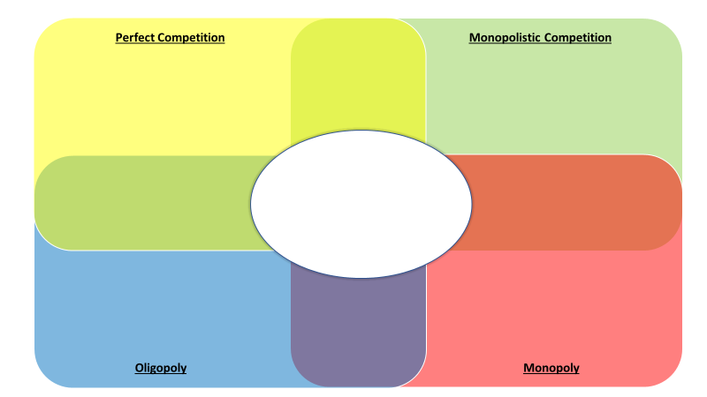

Activity 2, Handout 4: Completed Venn Diagram (on-level)
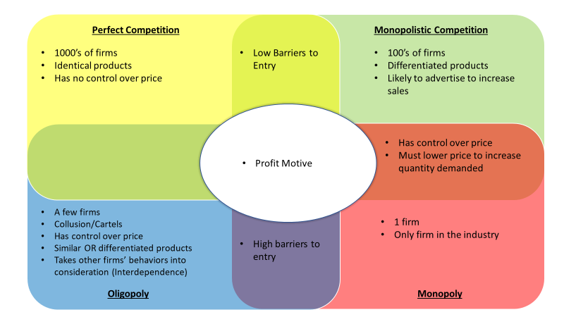

Activity 2, Handout 4: Completed Venn Diagram (AP)
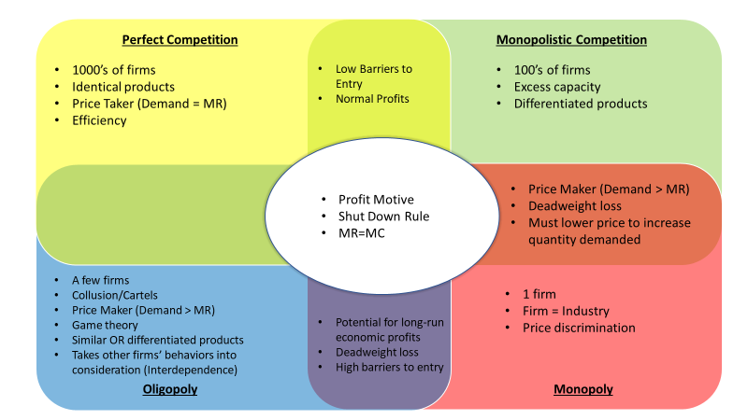

Activity 3, Handout 5: Braves Product Market Facts (cut out)
There is only one Major League Baseball franchise in Georgia. | Tickets to Braves games can be many different prices.
Tickets vary in price by date, location of seat, opponent, and other factors. | Tickets to a game can be purchased directly from the Braves on their website or at their box office.
Many websites re-sell Braves tickets online. | “Scalping”, or reselling tickets for an amount other than face value, is legal in Georgia if you are a licensed ticket re-seller OR the original purchaser of the ticket.
All tickets to a Braves game are originally issued by the Atlanta Braves. | The Braves and Truist Park are owned by the same organization.
The Braves set prices for all tickets and seats in Truist Park.
Many parking locations are available for Braves games. | For most games, parking prices range primarily between $8 and $21.
There are many parking lots close to Truist Park. | Many business parking lots near Truist Park have been leased by the Braves on game days.
There are a handful of independent parking lots and parking lot chains that offer game day parking. | Parking prices vary primarily based on distance from the stadium.
Many parking lots seem to offer similar prices for similar games. | Parking prices can vary by game.
There are many places to get bottled water in the stadium. | There are many small vendors selling bottled water out of coolers on the walk to the stadium.
Many of the smaller vendors outside the stadium are limited in how much bottled water they can sell by the size of their coolers. | All bottled water is the same price inside the stadium.
All independent vendors outside the stadium seem to be selling water at the same price. | The bottled waters all seem to be a standard size.
The bottled waters sold outside the stadium are often different brands. | All bottled waters for sale inside the stadium are the same brand.
There are several places inside the stadium to purchase Braves apparel of various brands and styles. | There are stands outside the stadium selling Braves apparel of various brands and styles.
There are many locations throughout the city that sell Braves apparel of various brands and styles. | The Braves have only licensed certain companies to use their logo for apparel.
Some independent vendors sell unlicensed apparel products, often at cheaper prices. | There are many licensed apparel companies including Under Armor, Nike, Majestic, New Era, ‘47, etc.
There are many different styles of shirts, hats, jerseys, etc. | Prices of apparel vary greatly depending on the style and brand.
Logos are prominently displayed on many of the pieces of apparel.

Activity 3, Handout 6: Market Structure Quadrant Sheet

Perfect Competition | Monopolistic Competition
Oligopoly | Monopoly

