Gadgets in Cannonland: Demand

Activity Description
In this activity, students will complete a worksheet that asks them to graph a demand curve and then shift demand when underlying factors in the market change the overall demand for gadgets.

Essential Question
- What causes demand to shift?
- What is the difference between a change in demand and a change in quantity demanded?

Concepts
Law of Demand
Determinants (shifters) of Demand

Georgia Standards of Excellence
SSEMI2 Explain how the law of demand, the law of supply, and prices work to determine production and distribution in a market economy.
a. Define the law of supply and the law of demand.
b. Distinguish between supply and quantity supplied, and demand and quantity demanded
f. Identify the determinants (shifters) of demand (e.g., changes in related goods, income, consumer expectations, preferences/tastes, and number of consumers) and illustrate the effects on a supply and demand graph.

Objectives
The student will be able to:
- explain how a specific scenario can cause demand to increase or decrease
- differentiate between a change in demand and a change in quantity demanded

Time
20-30 minutes

Materials
- Gadgets in Cannonland: Demand

Procedures
- Direct students to complete the worksheet on the next page. The teacher can choose to have students work independently, in pairs, or small groups (having students work in pairs or small groups can be especially helpful when students are first learning about demand, as having a partner enables them to better discuss and think through the questions).
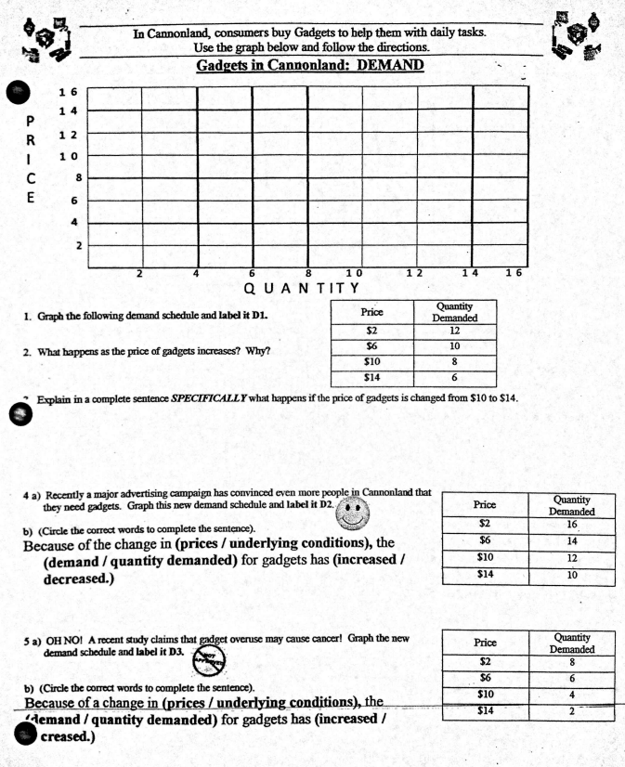
D3
D2
Specifically, the quantity demanded decreases from 8 units to 6.
Quantity demanded decreases because consumers are less willing/able to buy
D1

