gpb.org/lets-go-enviro

WHAT’S MY CARBON FOOTPRINT?
Trees play an important role in absorbing carbon emissions that come from humans, fire, decomposition, and fossil fuels. It is equally important, however, that the amount of carbon being released into the air is manageable-- meaning that there are enough trees or less carbon. One of the ways you can keep track of how much carbon you are contributing to the cycle is by determining your carbon footprint.
DIRECTIONS: On the sheet provided, create a pie chart that splits up your impact by section (such as school, home, hobby, and miscellaneous). Next, divide those sections by use. Consider everything you do on a regular basis and how that action uses energy or has a carbon footprint. You can write out or draw a symbol for each activity. Some examples include:
- In the school section you may take the bus, which has less carbon emissions compared to driving yourself to school every day.
- At home you may receive electricity from a plant that uses fossil fuels, so you would indicate how much energy you use. Or you may have more or less of a footprint based on the products you buy.
- In your hobby section, perhaps you have more emissions from activities like ATV riding, or less from playing an outside sport.

HOBBY
(Least amount of impact because does not have carbon emissions)

WORK & VOLUNTEERING
(Less impact than school because includes balance of carbon emissions)

HOME
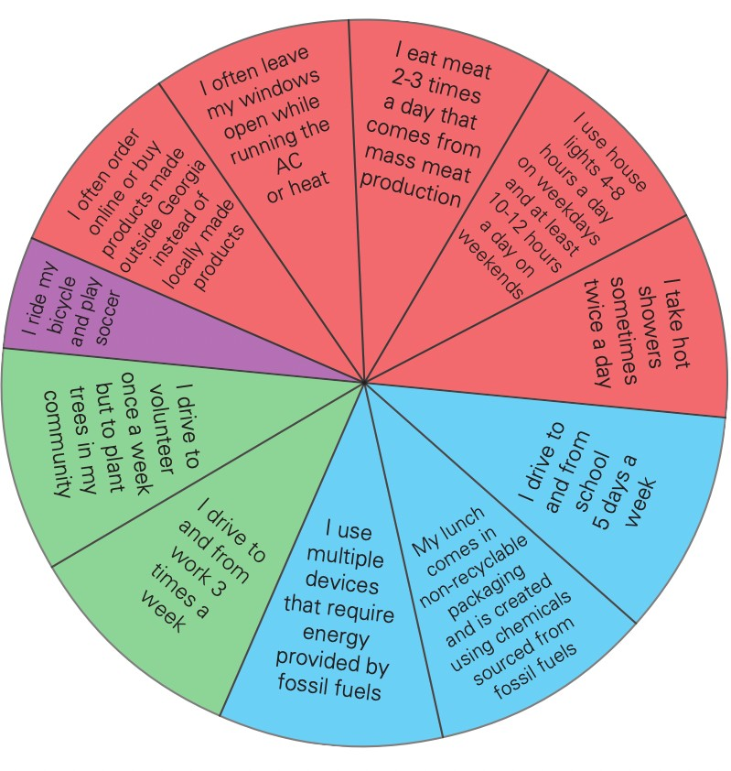
(Most impact because of everyday use of fossil fuels and purchasing imported items)

SCHOOL
(More impact than work but less than home since not year-round)

After you have identified your carbon footprint, below your pie chart, list three ways you can reduce your own impact. For example, you could plant a garden or tree, carpool more often, buy local, or use less electricity.

List three ways you can reduce your own impact.

