Name: Date:

gpb.org/water-journey

Student Guide: Develop and Use a Model of Caddisfly Communities

Engage: What are the living (biotic) and non-living (abiotic) components of this aquatic ecosystem?
Learning Targets: I can...
- develop a model to describe the cycling of matter and energy among living and non-living components of an aquatic ecosystem.
- analyze and interpret data from a simulation we design to construct evidence based explanations for the effect of human activity on an ecosystem.

Living Components |  | Non-Living Components
How might the energy flow between these components of the aquatic ecosystem?
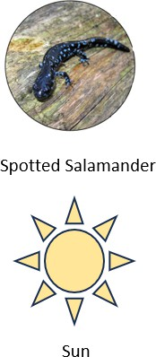
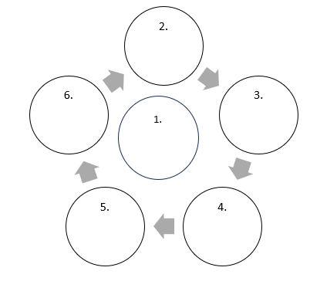
Organize the components into the flow chart.
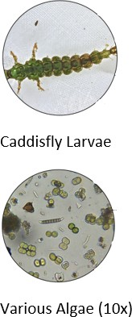
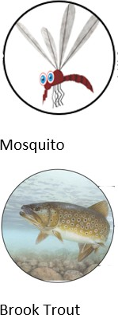

How might you improve the accuracy of this model to better show the multiple directions energy can transfer in the ecosystem? Improve the model to more accurately represent this energy transfer.

Explore: How might one community of species, the caddisfly larvae, affect the entire ecosystem?
As you gather information about caddisfly larvae, use metacognitive markers to support better understanding of the content.

Circle important language | Ask questions in the margin.
Write notes in the margin | Underline information that helps  answer the driving question.

Caddisflies are insects that live in aquatic habitats like rivers and streams. In Georgia, they especially like wetlands or creeks where there is slow-moving water. Other animals, like trout, eat caddisflies and their larvae.
An important adaptation that caddisfly larvae use to protect themselves from predators is building shells or shelters out of things they find in their environment.
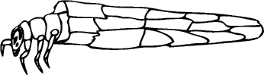
Caddisflies are also considered an indicator species.
They can tell us a lot about the health of our rivers and streams.

Sense-Making: How might human activity affect the caddisfly larvae? What do you predict will happen to the different communities in this ecosystem if humans polluted the environment?

Prepare to simulate the role of caddisfly larvae in an aquatic ecosystem. Draw a model of how you have used various materials to protect your caddisfly larvae from predators. Label the components of its protective shell.

Sense-Making: How well do you think your protective shell will prevent it from being harmed by pollution? How have others in your team created protective shells? Which components seem like they will be the most effective at providing protection from both predators and pollution?

Simulate: Once your group is ready, collect data for a minimum of 3 data sets of the simulation. Organize your data in the table:

Time | Population of Caddisfly Larvae | Population of Trout | Other Observations
1
2
3

Gather Additional Information (Connecting Ideas):

Mechanism | Explanation | Drawing/Visual | Other Important Notes
Predator-Prey
Bioaccumulation
Carrying Capacity

Explain: How did the simulation provide insight to the possible affects of human activity on an aquatic biome? Make your thinking visible by organizing your ideas into the cause-effect graphic organizer. Requirements for what to include in your explanation are outlined below:
Effect
Describe the phenomena. Use data from your simulation as part of your description.
Mechanisms
What are the processes that connect the causes to the effect/ phenomena?
Cause(s)

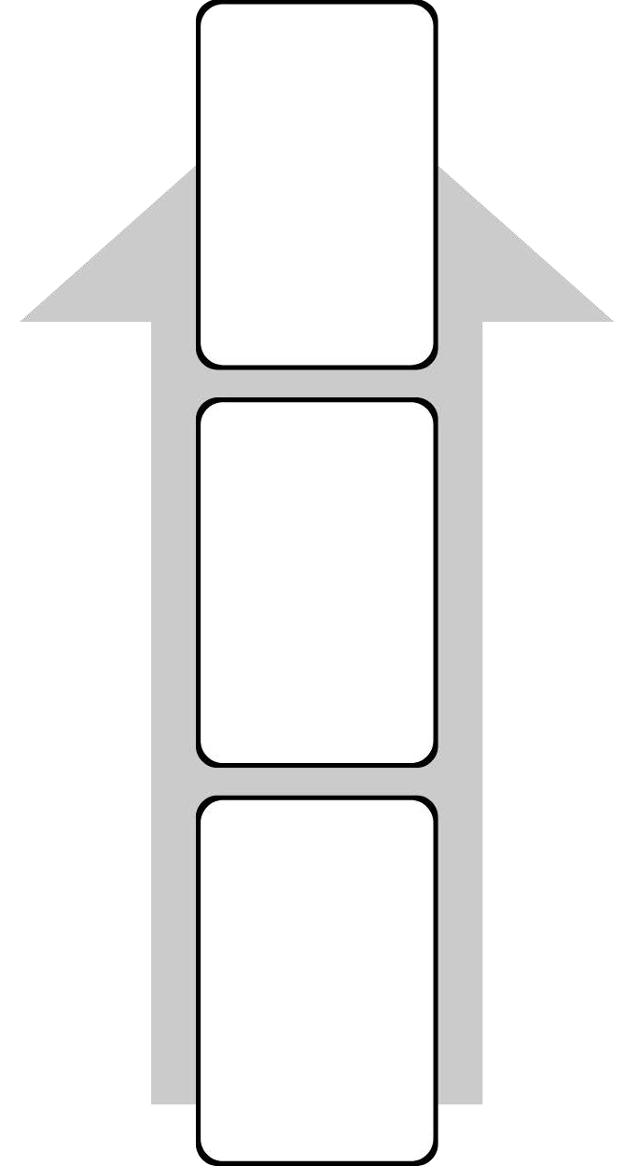
Cause(s)
Effect
Mechanisms

