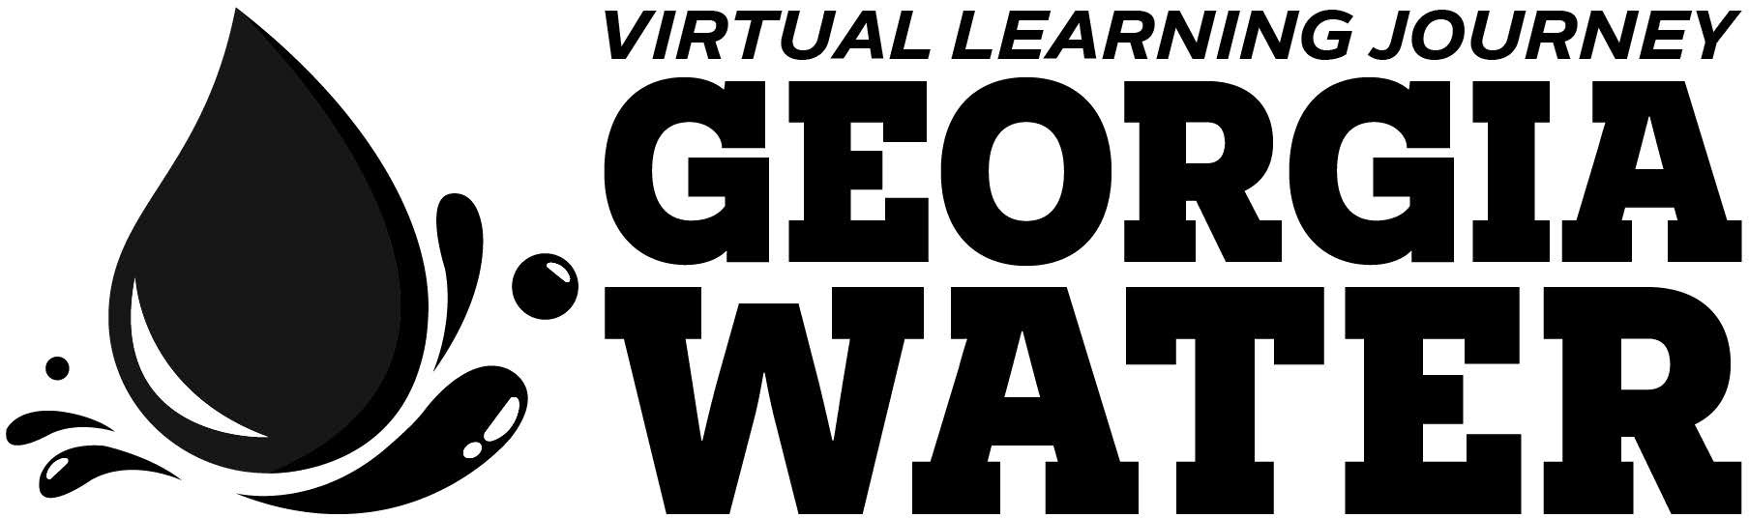

gpb.org/water-journey

Lesson Title | Water Purification Investigation
Timeline | 1-2 45-minute class periods
STANDARDS
5th Grade:
S5P1. Obtain, evaluate, and communicate information to explain the differences between a physical change and a chemical change.
- Plan and carry out investigations of physical changes by manipulating, separating and mixing dry and liquid materials.
Earth Science:
S6E6. Obtain, evaluate, and communicate information about the uses and conservation of various natural resources and how they impact the Earth.
- Design and evaluate solutions for sustaining the quality and supply of natural resources such as water, soil, and air.
Life Science:
S7L4. Obtain, evaluate, and communicate information to examine the interdependence of organisms with one another and their environments.
- Develop a model to describe the cycling of matter and the flow of energy among biotic and abiotic components of an ecosystem.
- Analyze and interpret data to provide evidence for how resource availability, disease, climate, and human activity affect individual organisms, populations, communities, and ecosystems.
Physical Science:
S8P1. Obtain, evaluate, and communicate information about the structure and properties of matter.
- Construct an argument based on observational evidence to support the claim that when a change in a substance occurs, it can be classified as either chemical or physical. (Clarification statement: Evidence could include ability to separate mixtures, development of a gas, formation of a precipitate, change in energy, color, and/or form.)
MATERIALS LIST
- pen or pencil
- student guide
- various watershed "pollutants" (small pieces of litter, food scraps, food coloring, cooking oil, sprinkles)
- various filtration materials (e.g., mesh cloth, cotton balls, sand, soil, small/large pebbles)
- water pitcher (for mixing pollutants)
- water
- coffee filter
- clear jar or plastic 2L bottle cut in half
- funnel
INTRODUCTION

Cleaning water so that it is safe to drink and use for other human consumption can be very simple. This cleaning process is often referred to as water treatment or purification. To begin the process, we take water from the natural environment where it flows, like a river or lake, and pipe it underground to a water treatment facility to filter out all the harmful pollutants and microorganisms. Through many steps and processes, water becomes cleaner and cleaner until it is ready to head to homes and schools through drinking water pipes. This simulation will give students an opportunity to directly observe processes leading to better understanding of filtration and how clean, safe water gets to their homes and schools.
This simulation is for both elementary and middle school students, from 5th-8th grades. Instructors will gather supplies, make explicit the purpose and relevance for carrying out this investigation, and support students in the development of their plans to carry out a simulation of water purification processes.

EXPLAIN
Before beginning, instructors should prepare for differentiation of process to meet students' needs. Please note that the standard is for students to plan and carry out the investigation, design and evaluate solutions, and analyze and interpret data. Consider whether your students’ readiness indicates they should practice an open or structured investigation. A student guide for each has been developed.
After previewing the options, you may decide that your students need a little less structure but are not quite at the level of open inquiry. Editing the document to meet your students’ needs is ideal. Please note: Materials needed will vary based on whether you choose a structured or open investigation. For example, with an open investigation, students may request different supplies than those that are in the structured investigation.
No matter the level of inquiry you support students in working through, you will need to prepare a pitcher or tank of polluted water to be used as the “collected water sample from nearby creek” throughout the learning process. If you decide to do this prior to the learning cycle, then you may want to discuss with students what each item may represent. If you work with students to create the "polluted" water, then facilitate discussion to decide what each item may represent. Here are some examples:
- Sesame seeds or similar spices can represent dirt or sediment in the water.
- Cooking oil or honey can represent car oil that washes off roadways during storm events.
- Rainbow sprinkles and other candies can represent plastics, like water bottles, bags and other items that may wash or blow into waterways.
- Chocolate pieces can represent pet waste that didn’t get cleaned up.
As you add each “pollutant,” discuss with students how that item may have ended up in the water as you add it to the pitcher.

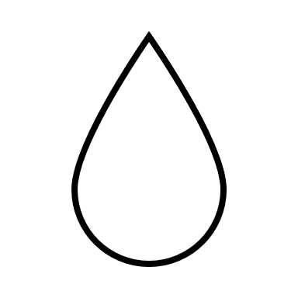
ENGAGE

Prior to the activity, instructors should also have students watch the "Johns Creek Environmental Campus:
Wastewater Treatment" video from Georgia Public Broadcasting’s Georgia’s Water Virtual Learning Journey. The video can be found at gpb.org/water-journey.

PART 1
Activate prior knowledge about properties of water that are safe for different living things, and then provide time for
students to gather information (see student guide). Consider providing specific resources about ideal properties for macroinvertebrates, indicator species, and other aquatic life in contrast to properties necessary for human consumption. Once information has been gathered, facilitate discussion about what qualifies as healthy water quality for an overall healthy ecosystem. Pose the question, "If aquatic living things need slightly different things about their water than we do, then how do we make it safe for us to drink?"

PART 2
Provide students with samples of the “collected water from the nearby creek.” Provide time in the alone zone for students
to notice and wonder (see student guide), and then allow for table talk followed by whole group sharing. As students begin to share their ideas for how they can gather more detailed information, show/demonstrate use of various tools that measure properties like pH, ppm, dissolved oxygen levels, etc.
The use of a microscope is encouraged to gather information about (observe) micro particles and microorganisms. Therefore, if your students have not used a microscope before, then you may want to use this opportunity for direct instruction on how to prepare slides, focus, and draw observations.

EXPLORE
Option for Open Investigation: Support students as they use tools to gather additional information about the properties of the collected water sample. All answers will vary depending on the materials used to simulate a polluted water sample. (Please note: This version is most consistent with meeting the science and engineering practices of the standards.)

Option for Structured Investigation: There are several ways to provide more structure for students as they collect data about the properties of the collected water. For example, you may want to work whole group with students to demonstrate how to use one of the tools, and then monitor as students collect that data for that property. As another example, you may want to ask students to assign roles in their group. One role might be the facilitator. The facilitator's responsibility would be to learn how to use the tools (in small group instruction with you), and then re-teach their home group, giving each of their group members an opportunity to learn how to use and record the data.

EXPLAIN
Through questioning and discussion, transition students to make connections between the qualities of their water samples and the requirements for human consumption (see "Engage" phase).
Option for Open Investigation: An organizer is outlined for students to use in organizing their evidence- based claims about the quality of the water sample.

Option for Structured Investigation: Student sentence starters and narrowed choices for evidence have been included in the organizer for students to use in developing their evidence-based claims about the quality of the water sample.
Anticipated Answers:

Inial Claim | This sample of collected water is unsafe/not safe  for humans to drink.
Supporng Evidence
Color: | Presence of Macro Parcles: | Presence of Micro Parcles:
blue (varies depending on your previous choices) | (Responses vary depending on how you simulated a polluted water sample.  A possible answer is provided.)  Litter, like plastic tops and pieces of chip bags  Something oily (separated on top of the water) | (Responses vary)  Large population of microorganisms (general identiﬁcation might have occurred if teaching life science resulting in more speciﬁc answers like bacteria, protista, insect larvae)  Microplastics (sprinkles)
Reasons this Evidence is Connected to the Claim
The color of water should be transparent/clear, but this water is blue. | The risk of choking and indigestible nature of large pieces of plastic  litter makes these macro particles in the water unsafe for drinking.  Oil is considered a contaminant in water and is unsafe for humans to drink. | A large population of microorganisms is a sign of an unhealthy ecosystem. Depending on the species of the microorganisms, like  E coli, it is additionally unsafe for humans.  E coli and other microorganisms cause diarrhea, vomiting, and stomach cramps for humans.

Modified Engineering Design Cycle

ELABORATE

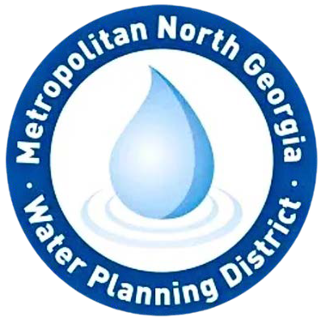
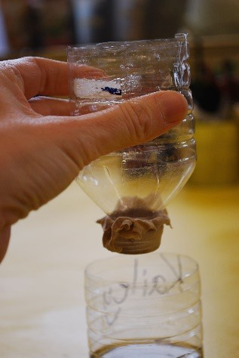
IDEATE/DESIGN A PROTOTYPE
Option for Open Investigation: As students brainstorm ideas for purifying the water, walk around to groups to guide their decisions by asking questions like:
- Why are you thinking will work?
- Why do you think will filter out?
- How do you think using two materials at once might impact your ability to know which worked best?
- Have you considered tiering your purification system? For example, what if you used filter in the first layer and then filter in the second layer?

Then you will have a better idea of what contaminants are being filtered by the materials. Space for students to develop a model of their prototype is provided. As you talk with groups, encourage labeling.
Option for Structured Investigation: Facilitate whole group discussion to elicit student thinking about the best material for filtering the water. Anticipate cloth as one of the more common ideas. Develop an initial prototype that you prefer for students to simulate in their purification systems (see figure as an example). Model for students how to develop the model in the space provided on their student guide. Once completed, consider allowing students to recreate the prototype in their groups.

RESULTS OF DESIGN 1
Option for Open Investigation: As students test their ideas, walk around to support students in thorough and accurate
records of their outcomes. As they begin to consider ways to improve their prototype, consider pausing their work to facilitate whole group sharing of outcomes. After groups share their outcomes, encourage students to use other group outcomes in their new decision making for design 2.
Option for Structured Investigation: Pour the collected water sample through the purification system to show students that the cloth filters some things, but not all things. Model for students how to record the results in their data table. Next, guide whole group conversations about how other materials might be successful at filtering additional contaminants.
Consider allowing different groups to choose different materials to test. This will lead to richer whole group conversations after design 2 is tested.

DESIGN 2/RESULTS OF DESIGN 2
Option for Open Investigation: As students develop models and test their new ideas, walk around to support students in
thorough and accurate (labeled) models and records of their outcomes. Again, as they begin to consider ways to improve their second iteration, consider pausing their work to facilitate whole group sharing of outcomes. After groups share their outcomes, encourage students to use other group outcomes in their final explanation/communication of findings.

Option for Structured Investigation: Share with students that you have decided to make your purification system include small pebbles in addition to the cloth filter. Draw a model of this improved prototype where students can see. Explain to students that you have chosen small pebbles because you think the oil will stick to the rocks as the water passes over. (Choosing something that will not work supports a later conversation about the importance of learning from both successes and failures.) Then, ask groups to share with the class materials they have selected and their rationales.
Provide time for students to develop their new labeled prototypes in the space provided on the student guide.
Once completed, pour a water sample through the improved purification system. Record outcomes in the data table, modeling for students how to complete this portion once they test their own ideas. Provide time for students to test their ideas and record their outcomes in the data table. As students test their ideas, walk around to support students in following through with the test and data collection.
Next, guide whole group discussion about how well the designs worked. Remind students that it is important to learn from both successes and failures. Provide time for students to use all these outcomes as they think through and record what a third design might include (see student guide).

© Georgia Public Broadcasting. Developed by Amy V. Gilbert, PhD. 4

EXPLAIN
COMMUNICATE FINDINGS:
Provide time for students to draw the most effective design in the space provided (see student guide). Students should
be supported in using other group designs as their explanations, especially if their designs were ineffective. Evidence and reasons will vary for students depending on what they have determined is the best design. A possible student explanation is provided below as a guide:

Best Design
(include labels)
Supporng Evidence
Color improved | Sprinkles (microplascs) removed | Fewer microorganisms observed under the microscope (only 1)
Reasons this Evidence is Connected to the Claim
Water should be clear for it to be safe for humans to drink. This design created the clearest water. | Microplascs bioaccumulate in our digesve systems and cause serious health problems. This design removed all the sprinkles, aka microplascs. | Certain bacteria and prosta are harmful to humans. With fewer microorganisms the water is potenally safer to drink.

SUMMARY

Provide students individual processing time to consider their responses to the following prompts outlined in their student guide:
Do you think your purified water is clean enough to replace in the creek? Things to consider in your response: How might your purified water affect microorganisms in the creek? How might your purified water affect larger organisms, like crayfish or fish?
Do you think your purified water is clean enough for humans to drink? Explain your thinking. Consider follow up with whole group discussion/reflection for students to share aloud their thinking.

POSSIBLE ELABORATION:
Research how the water utility in your area filters water. Many water utilities are willing to come to schools to speak to
students or will even answer questions sent in about the water filtration process. Have students consider the sources of drinking water in their area.
- What kind of filtration/cleaning processes does your drinking water go through before it comes to your tap?
- How does your water utility test the water throughout the filtration process?
- How does this activity make you think about keeping source water or natural water clean? Is it harder, more time consuming, or more expensive to filter water that is more polluted to begin with?

© Georgia Public Broadcasting. Developed by Amy V. Gilbert, PhD. 5

