Name: Date:

gpb.org/water-journey

Student Guide: Develop and Use a Model of the Hydrologic Cycle

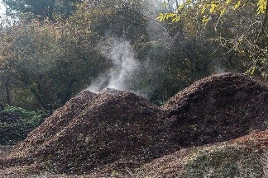 | 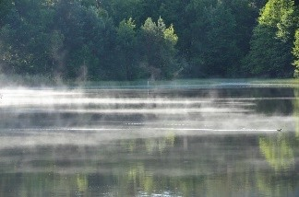 |  | 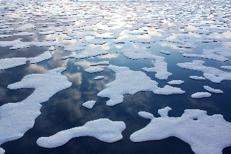
What do you notice? |  | What are you wondering?
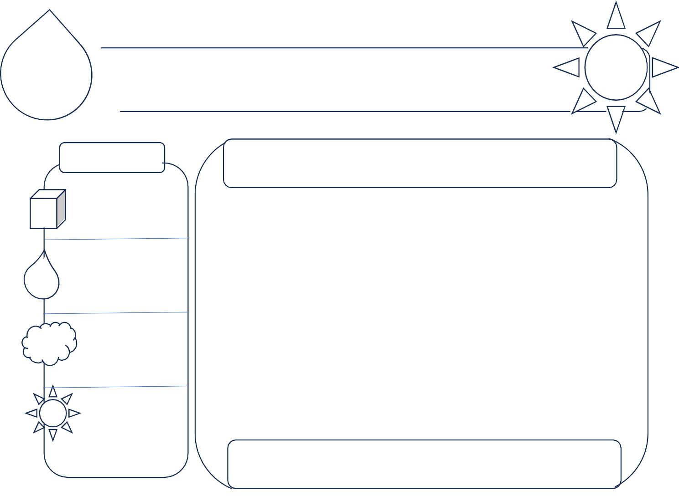
Choose one phenomenon from the photographs to better understand. Organize what you understand about the phenomenon in the graphic. (Reminder: You will revisit this several times in the lesson.)

Describe the
Phenomenon
.

Components

Define the boundaries of the system.
Draw and label all components.

Identify relationships between the components.

© Georgia Public Broadcasting. Developed by Amy V. Gilbert, PhD. 1

Explore: Recreate one of the systems from the engage phase. Place all components of the system in a sealed baggie. Draw and label your system set-up:
system is in sunlight?
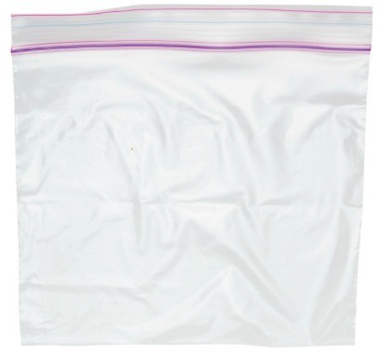

Mass of Sealed System: | grams
Starting Temperature: |  | Celsius

What do you expect to occur when the sealed system is in sunlight?  Sunlight Predictions | What do you expect to occur when the sealed system is out of the sunlight?  NO Sunlight Predictions

Explore/Explain: Observe the closed system in sunlight for several days. Record all observations!

Day | Mass (g) | Temperature of Bag (C) | Sketch of Observations | Evidence of Water in Different Phases | Evidence of Water Moving (use arrows)
Note: If you observe water moving, use a permanent marker to draw arrows that show where the water started and where it is now.

Gather and evaluate information about processes associated with the hydrologic cycle. Make connections from what you read to what you observed in your sealed system.

Language | Explanation | Connection to My Observations

Revisit your graphic organizer on page 1 after each day of observations. Add components and relationships to show new or different information that you now know.

Summary:

- What role did adding sunlight energy have on the (phenomenon) system?

- How do you think your outcomes would have been different if your system had no sunlight?

