gpb.org/water-journey

Lesson Title | Develop and Use a Model of the Hydrologic Cycle
Timeline | 1-2 45-minute class periods
STANDARDS

4th Grade:
S4E3. Obtain, evaluate, and communicate information to demonstrate the water cycle.
- Plan and carry out investigations to observe the flow of energy in water as it changes states from solid (ice) to liquid (water) to gas (water vapor) and changes from gas to liquid to solid.
- Develop models to illustrate multiple pathways water may take during the water cycle (evaporation, condensation, and precipitation). (Clarification statement: Students should understand that the water cycle does not follow a single pathway.)

Earth Science:
S6E3. Obtain, evaluate, and communicate information to recognize the significant role of water in Earth processes.
b. Plan and carry out an investigation to illustrate the role of the sun’s energy in atmospheric conditions that lead to the cycling of water.
S6E4. Obtain, evaluate, and communicate information about how the sun, land, and water affect climate and weather.
- Analyze and interpret data to compare and contrast the composition of Earth’s atmospheric layers and greenhouse gases.
- Plan and carry out an investigation to demonstrate how energy from the sun transfers heat to air, land and water at different rates.

Life Science:
S7L4. Obtain, evaluate, and communicate information to examine the interdependence of organisms with one another and their environments.
b. Develop a model to describe the cycling of matter and the flow of energy among biotic and abiotic components of an ecosystem.

Physical Science:
S8P1. Obtain, evaluate, and communicate information about the structure and properties of matter.
b. Develop and use models to describe the movement of particles in solids, liquids, gases, and plasma states when thermal energy is added or removed.

MATERIALS LIST
- student guide
- plastic zip baggie
- permanent marker
- miscellaneous organic material
- window with sunlight
- digital IR thermometer
- digital scale/triple beam balance
- water
- ice
- food coloring (optional)
INTRODUCTION
What is the hydrologic cycle? The hydrologic cycle, or more commonly referred to as the water cycle, is the process through which water moves continuously through the earth and its atmosphere. The three main processes of the
hydrologic cycle- evaporation, condensation, and precipitation- are all influenced by adding and removing thermal energy from air, land, and water sources at different rates. All living things rely on the hydrologic cycle to keep our surface
waters full, and our groundwater replenished.
Before beginning, instructors will need to gather supplies and support students through sense-making either in groups or individually.

ENGAGE
Use the photo splash to elicit student thinking about the interactions of sunlight and water on earth. Then facilitate discussion using general questions like, “What did you notice?” “What are you wondering?” Anticipate for students to notice water and sunlight are part of each photograph. Transition by asking, “What role do you think the sunlight plays in making the water do different things?”

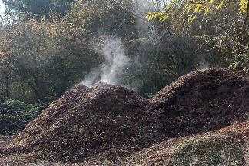 | 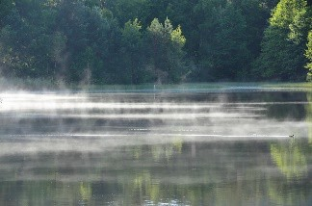 | 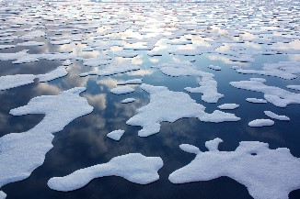
Mulch | Pond | Sea Ice
Provide individual time for students to record their initial thinking in the graphic organizer outlined in the student guide. Encourage students as they are writing. Remind them that they will continue to add new and different ideas as they work through the lesson.

Explore:
Provide explicit instruction on types of systems, and the need for understanding this to be successful at recreating one of the phenomena from the photo splash. As you provide this instruction, you may find the following visual representations useful in your explanations.

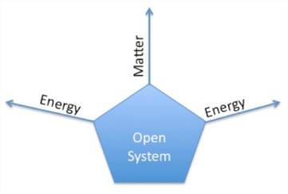  Open | Closed | Isolated
 | 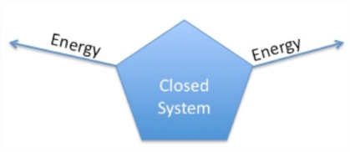 | 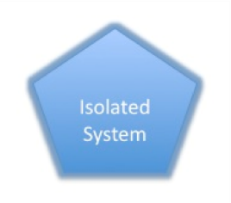

After instruction, ask, “What type of system is each of our phenomenon in the photographs?” If students indicate that the phenomena are open systems, then consider teaching and/or re-teaching the role of the atmosphere in "closing" off Earth from any matter entering or leaving. Use this as opportunity to also emphasize the ability of electromagnetic energy from the sun to enter and leave Earth’s (closed) system.
Provide time for students to look through the materials for which they can use to re-create one of the systems from the engage phase (see suggested materials). Ask, “How can you set it up so that no matter enters or leaves, but energy can come and go?”
Provide student choice and time to recreate one of the systems from the engage phase. Provide ice and/or organic material as needed.

Next, support students in recording the mass and starting temperature of the sealed system. Consider using digital scales and/or triple beam balances and a digital infrared thermometer, depending on your time and available instruments.
Before moving the sealed baggie to a source of sunlight, ask students to predict what they will observe as sunlight moves in and out of the area where the systems will be taped. Provide time for students to record these predictions in their student guide. Encourage students to include in their predictions how mass and temperature will/will not be impacted by sunlight/no sunlight.

Support students in taping their sealed systems to an area with sunlight.

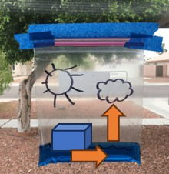
EXPLORE/EXPLAIN
Support students in recording day 1 observations (see student guide). It may be useful to model for students how to draw arrows to show any evidence of water moving with arrows and/or a change in phase. Below is an example outcome after day 1 for a student who may have chosen to recreate the sea ice phenomenon. This student’s bag would show that the ice melted to a liquid and that some vapor has also begun to be evidenced (bag feels fuller):

After day 1 observations are recorded, provide opportunity for students to gather, obtain, and evaluate information about processes associated with the hydrologic cycle (e.g., evaporation, melting, condensation, precipitation). This opportunity will support students in the language acquisition consistent with the standards.

Suggested Resources:
A general graphic organizer has been included in the student guide to support organization of information gathered.
However, further differentiation of this process is important for student success. Consider using multiple modalities and leveled text as appropriate.
Teacher Note 1: After each day of observations, students return to the provided resources and/or language acquired to include new/different labels and/or images on both their sealed system and in the graphic on page 1 of their student guide.
Teacher Note 2: Mass should remain consistent throughout the observations. Opportunity to pre-teach law of conservation is purposefully embedded here to support a natural space for enrichment.

SUMMARY
Support students in summarizing what they have learned by constructing explanations to the original phenomenon as prompted in their student guide:

- What role did adding sunlight energy have on the (phenomenon) system?
- How do you think your outcomes would have been different if your system had no sunlight?
Consider brainstorming with students a list of words to include in their explanations, provide sentence starters as appropriate, and encourage students to consistently refer to their phenomenon and the data/observations they collected to support their explanations.

Sample Explanation (by end of 8th grade):
Adding sunlight energy to the simulated sea ice system resulted in several physical changes. The sea ice system began as
solid water (ice) all in one cube located at the bottom of the sealed bag. It had a mass of 50 grams and a surface temperature of 52C. As sunlight energy was added in day 1, the solid water changed to liquid water, which filled the entire bottom of the sealed bag. The mass was still 50 grams, but the temperature had increased to 72C. The change in volume from solid to liquid provides evidence that adding sunlight energy can make particles move faster and away from each other. This process is known as melting. After the second day of observations, some liquid water was observed as gas, or water vapor. This was evidenced from both the droplets of water that were higher in the sealed bag and the poofy feeling of the bag that was not observed the day before. The poofy feeling is the most direct evidence of evaporation occurring. Since you cannot see gas particles, you would only be able to observe that they take up more space as the bag fills out. The bag increases in volume from the increase in pressure caused by how much more quickly the gas particles move. The droplets I observed are better evidence of condensation. Seeing the droplets higher in the bag means that the water evaporated, moving toward the top of the sealed bag, and then changed back to a liquid as it cooled. The mass of the sealed bag was still 50 grams, and the temperature had increased only a few degrees at 76C. In recreating the sea ice phenomenon, I observed that adding sunlight energy results in water changing phases and moving to different areas of the closed system.

